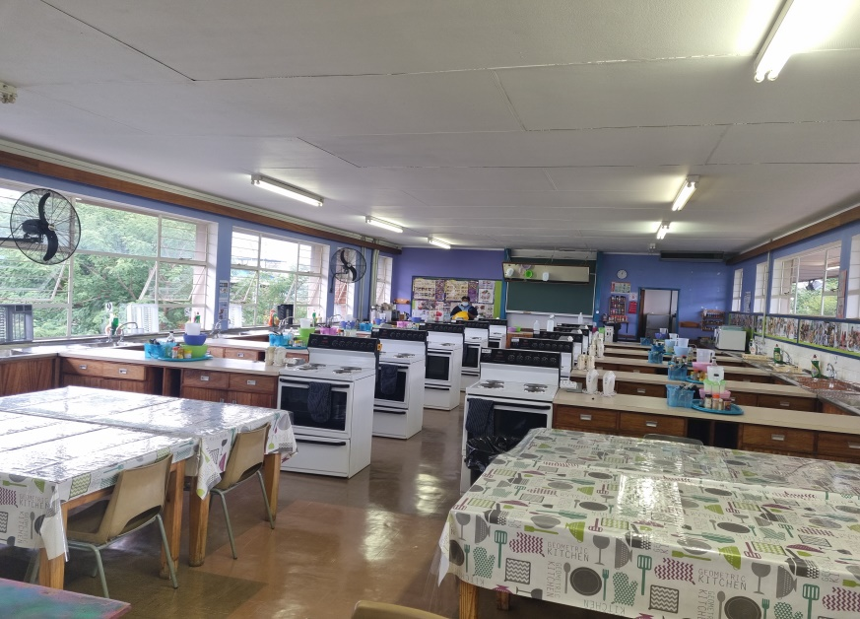
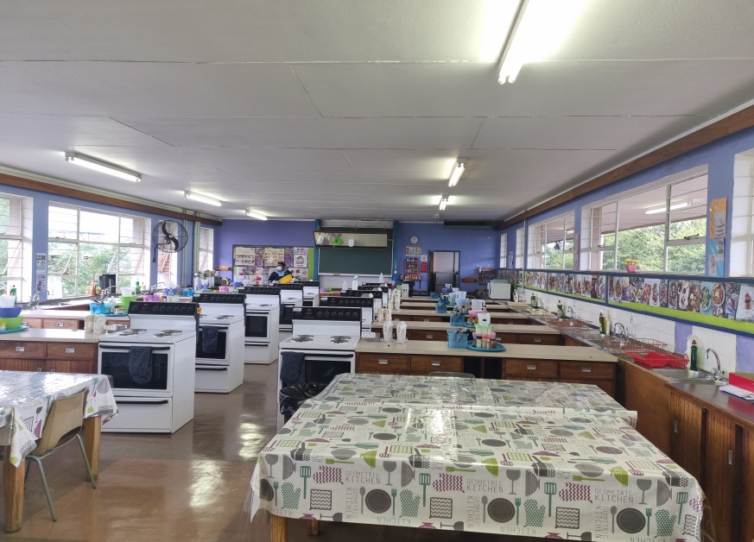
CONSUMER STUDIES CLASSROOM / HOTEL SCHOOL, EACH CLASSROOM EQUIPPED WITH 10 COOKING STATIONS
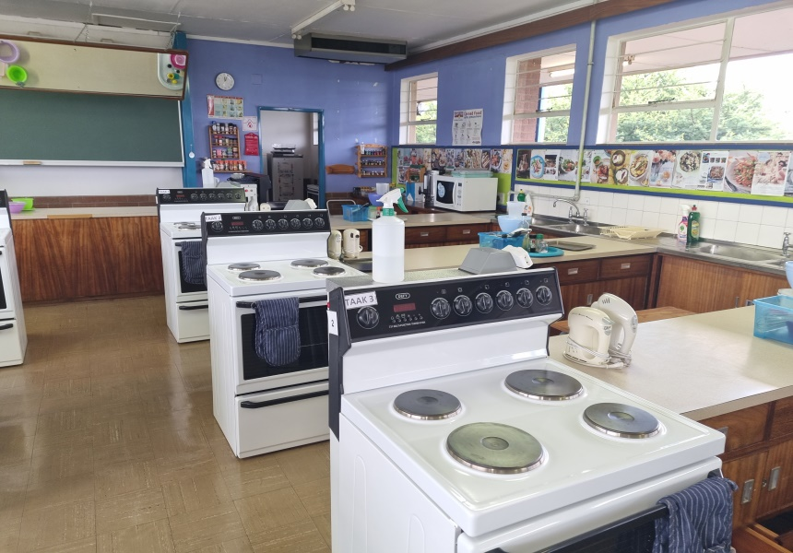
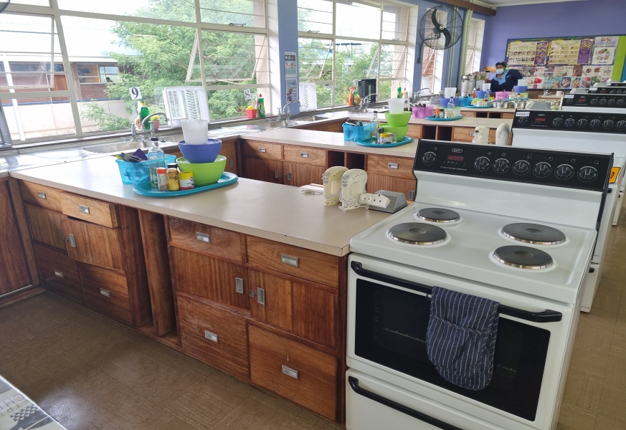
COOKING STATIONS

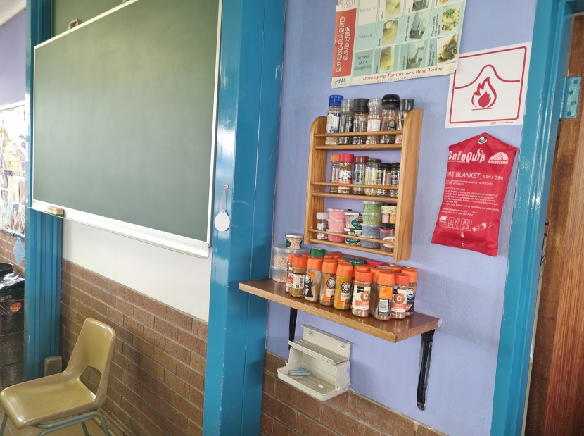
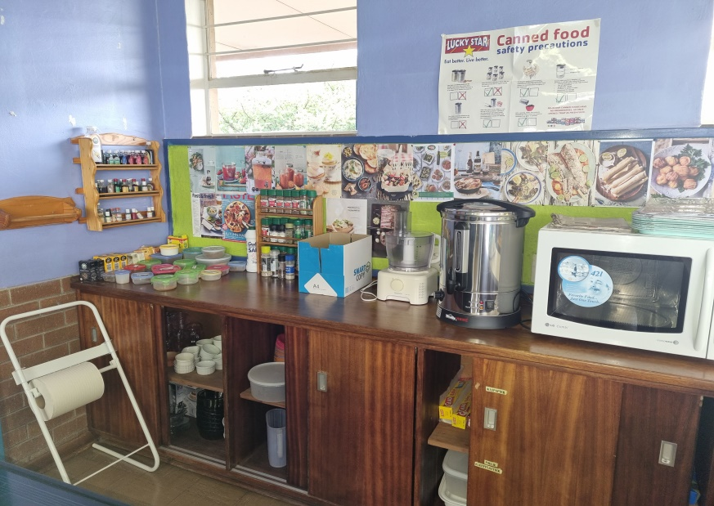
BACK OF CLASSROOM WITH MICROWAVE/COFFEE EARN/SPICES

