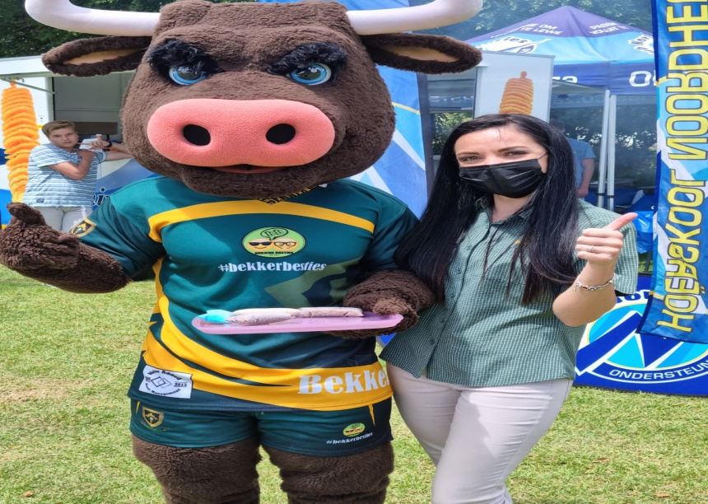
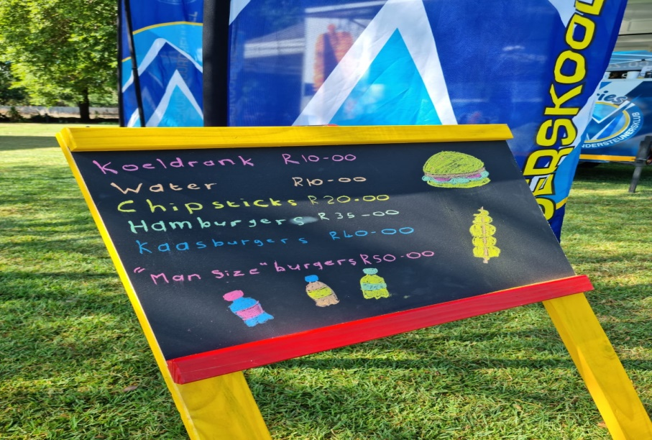
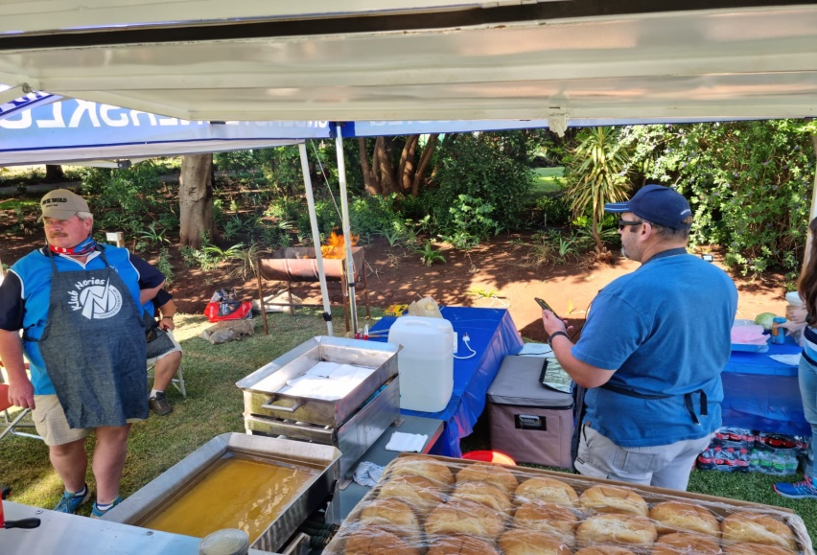
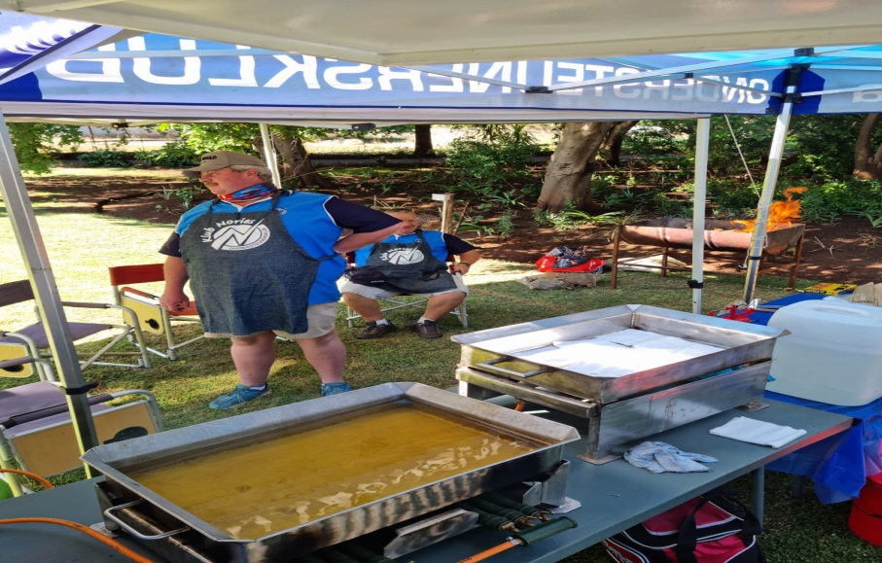
CATERING OUTSIDE WITH BURGERS/BOERIE ROLLS/ CHIPSTIX ETC
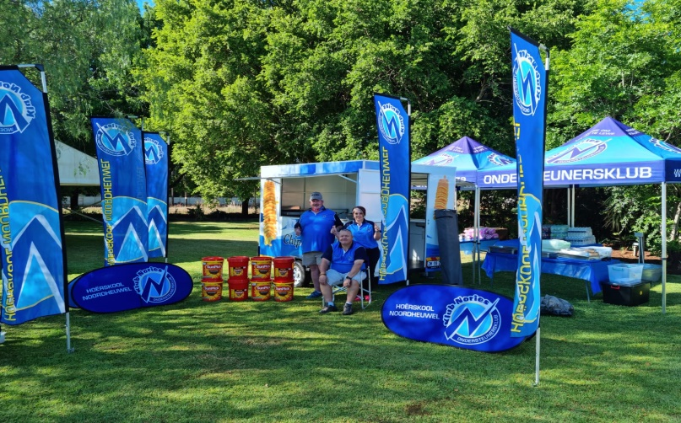
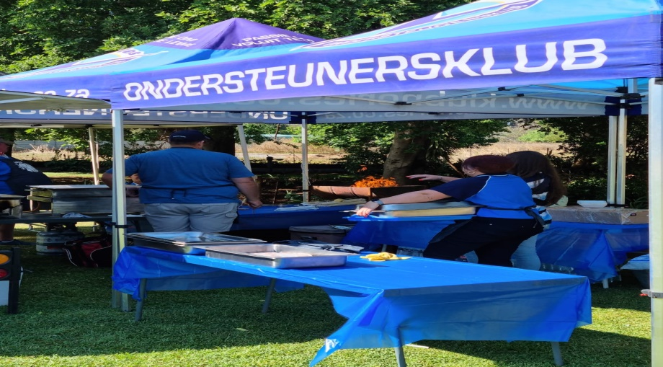
MENU SPORTS DAY FUN
FIRE’S GOING TYPICAL SET UP NEXT TO ESTABLISHMENT

