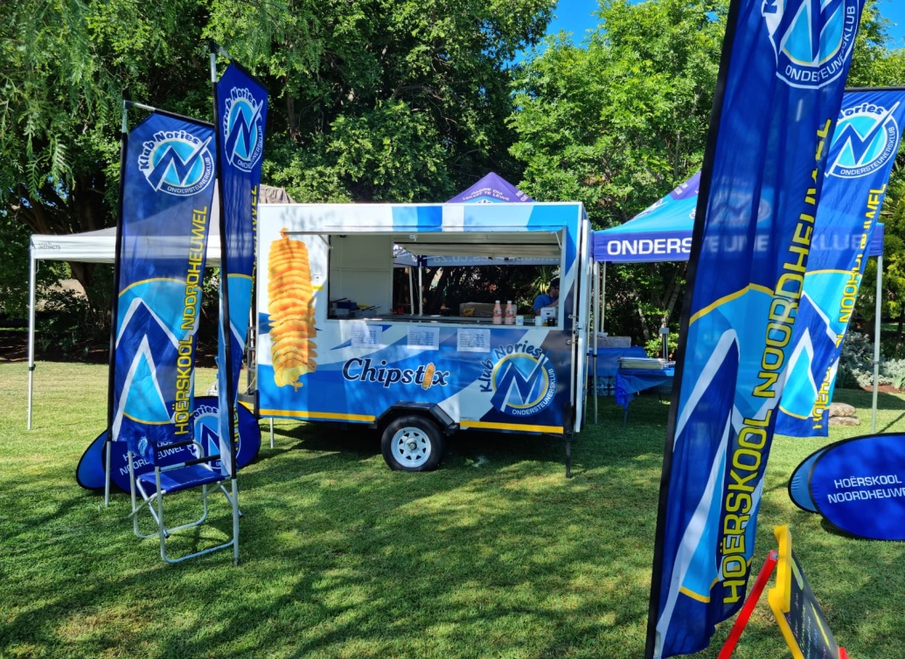
FOOD TRAILER THAT WILL BE PARKED NEXT TO THE ESTABLISHMENT
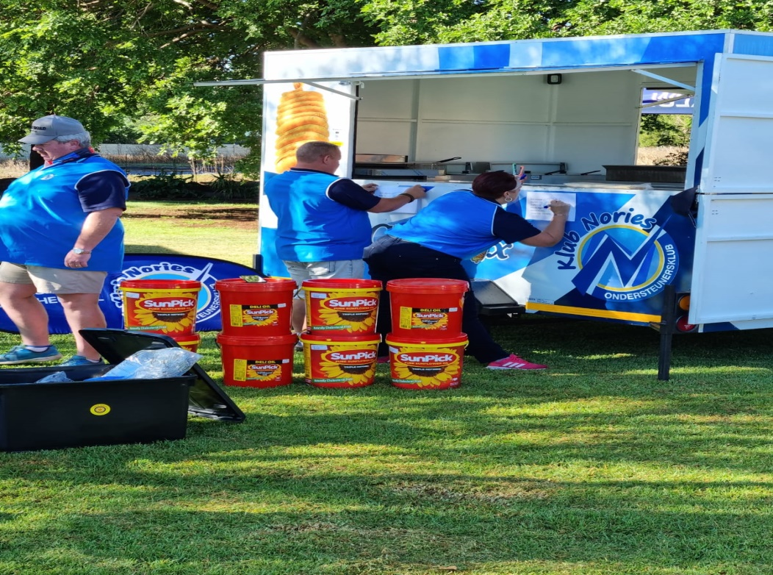
WITH VARIOUS GAZEBO’S

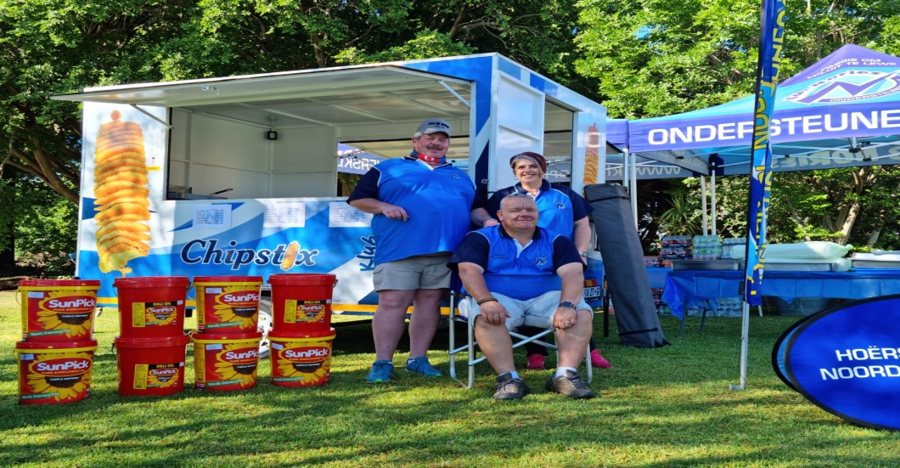
WRITING DOWN THE MENU

