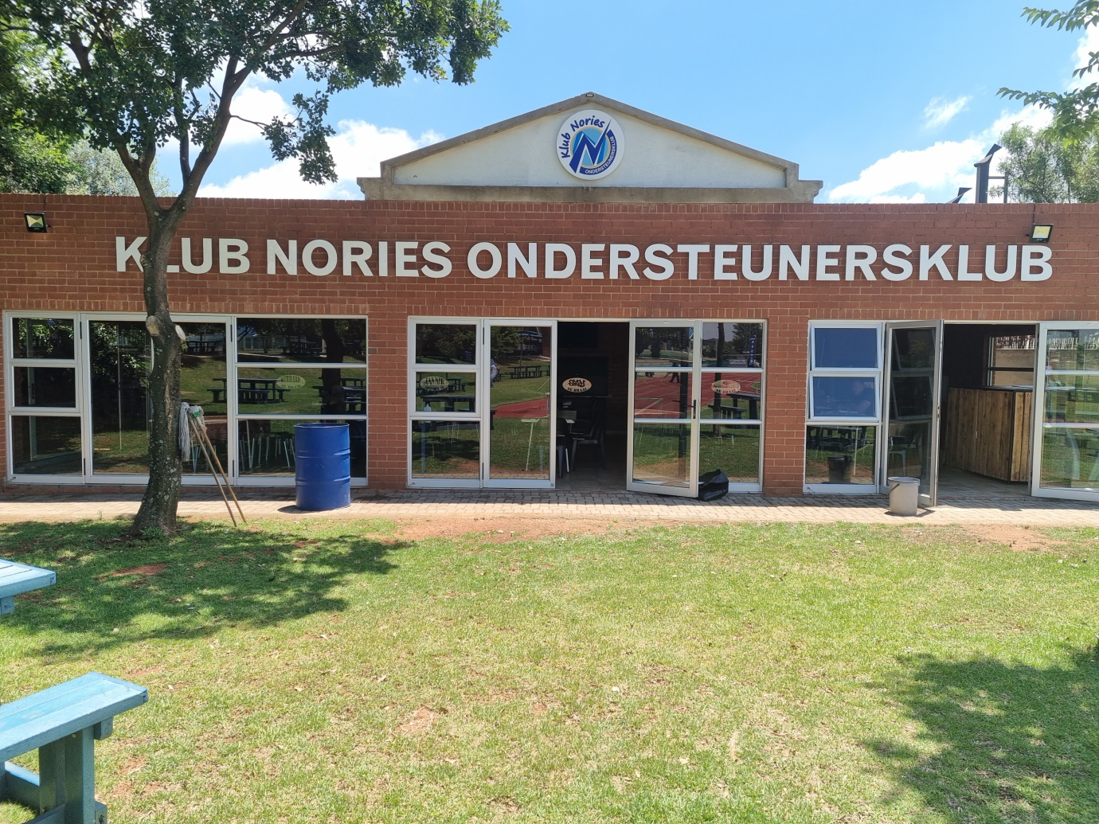
KLUB NORIES NPO
FRONT VIEW OF ESTABLISHMENT

