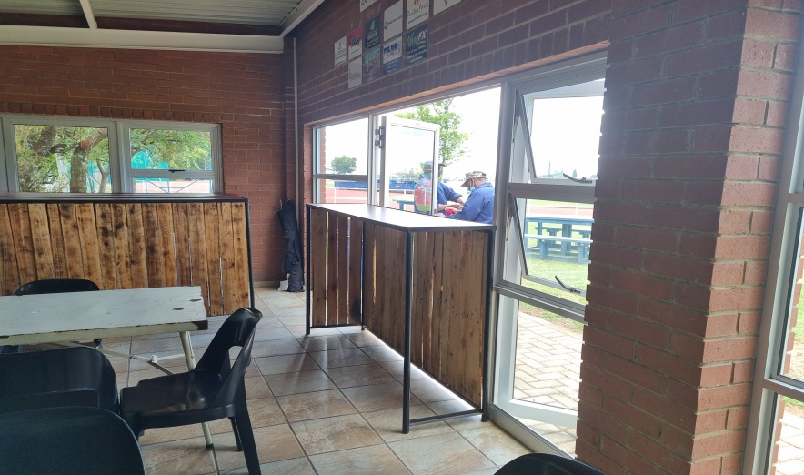
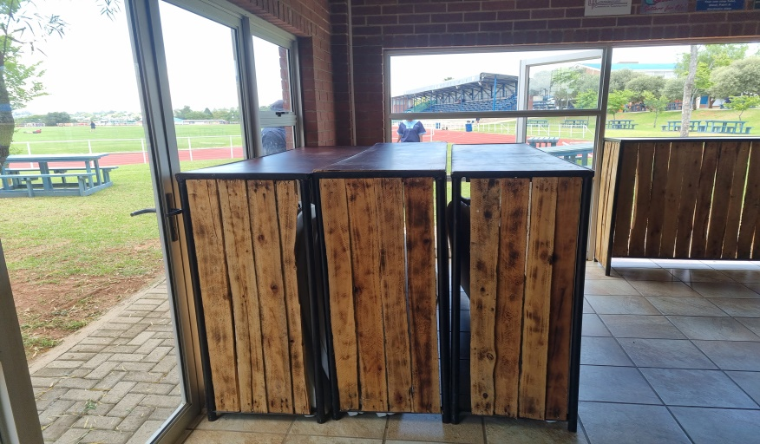
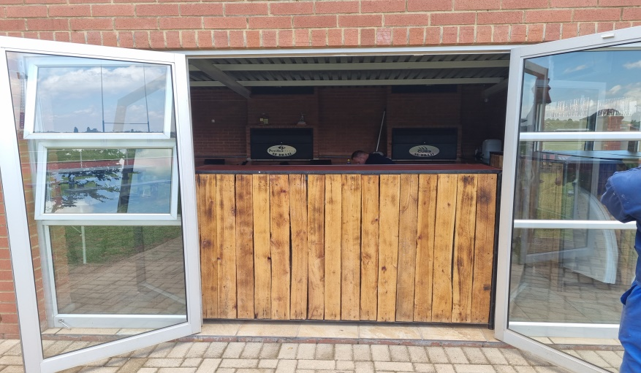
1ST PHOTO – BAR FACING THE OUTSIDE IN ONE OF THE DOORS
2ND PHOTOS – THE HAVE 4 BAR COUNTERS TO UTILISE
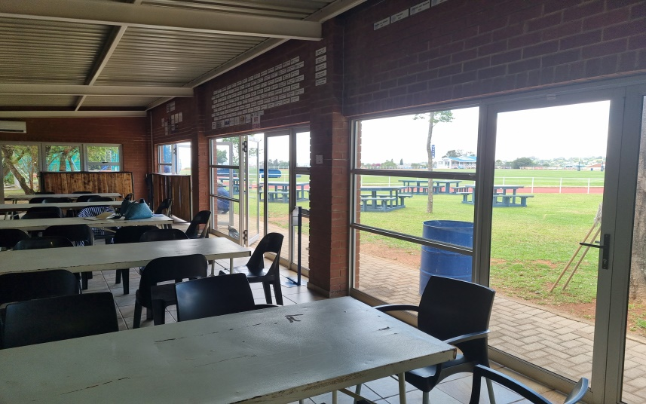
3RD PHOTO – BAR ON INSIDE AND ONE FACING OUTSIDE

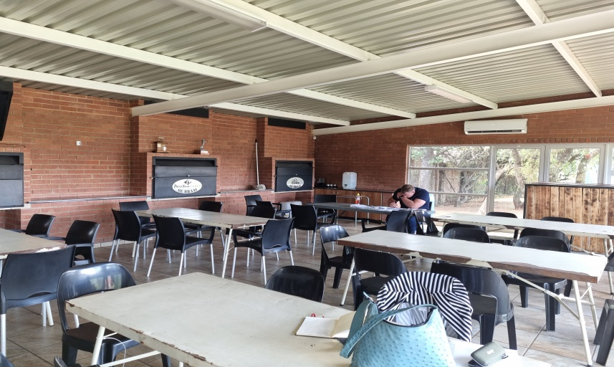
4TH PHOTO – STEEL TABLES WITH BLACK PLASTIC CHAIRS

5TH PHOTO – INSIDE BRAAI FACILITIES

