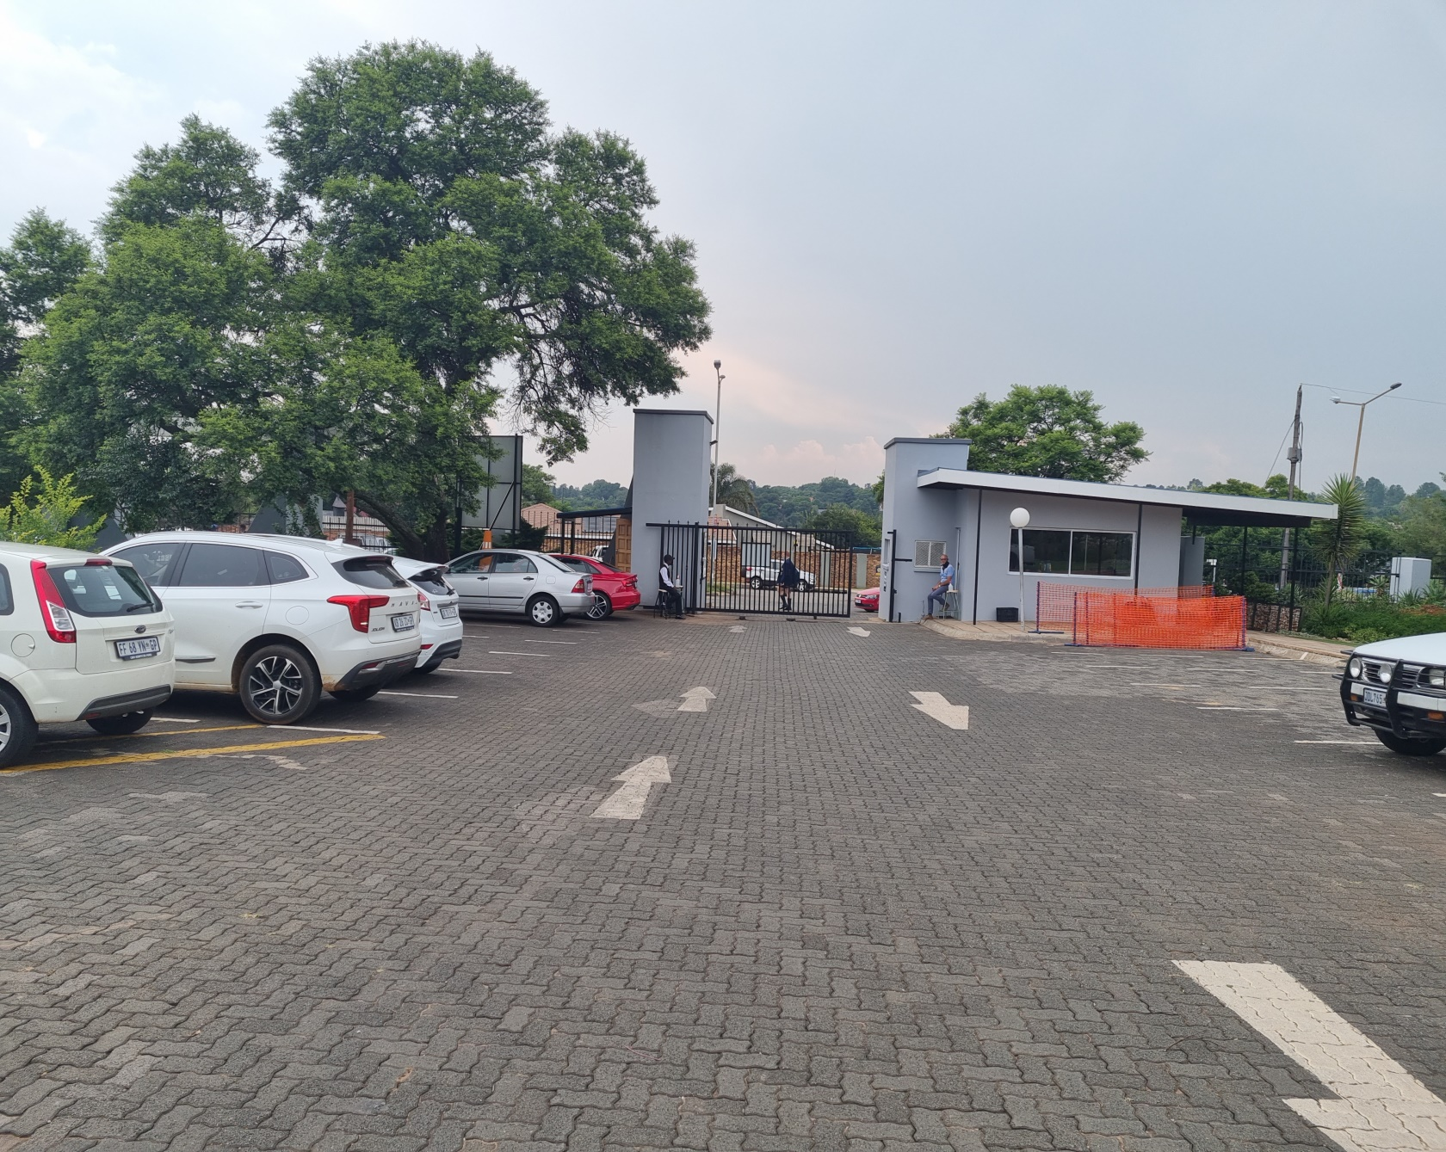
MAIN GATE WHERE THE ONLY ENTRANCE WOULD BE GAINED ONCE LICENSE IS GRANTED FOR STRICTER CONTROL AND ALCOHOL TO BE MONITORED.
NO MORE COOLER BAGS ALLOWED ON SPORTING EVENTS AS THERE WILL BE A CENTRAL POINT WHERE ALCOHOL WILL BE SOLD.

