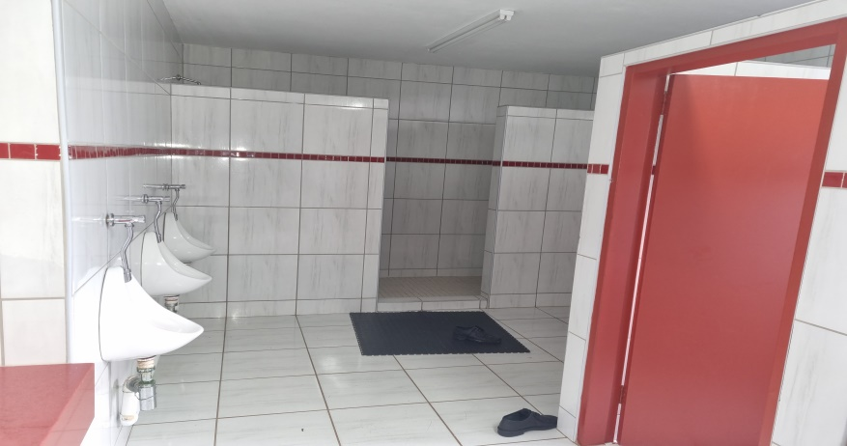
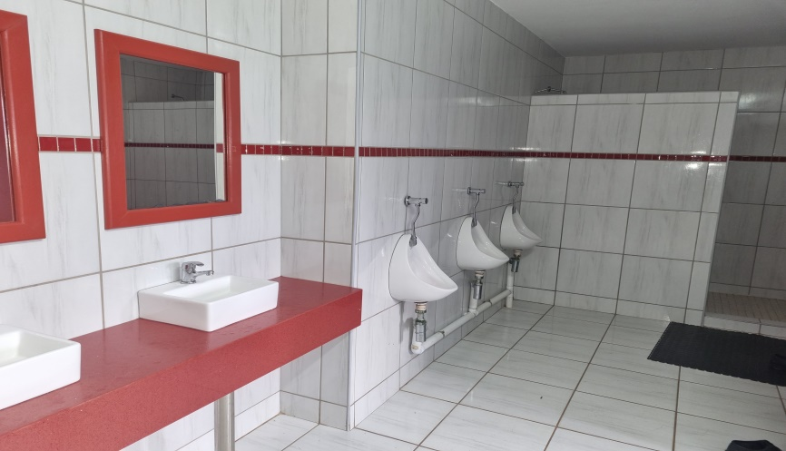
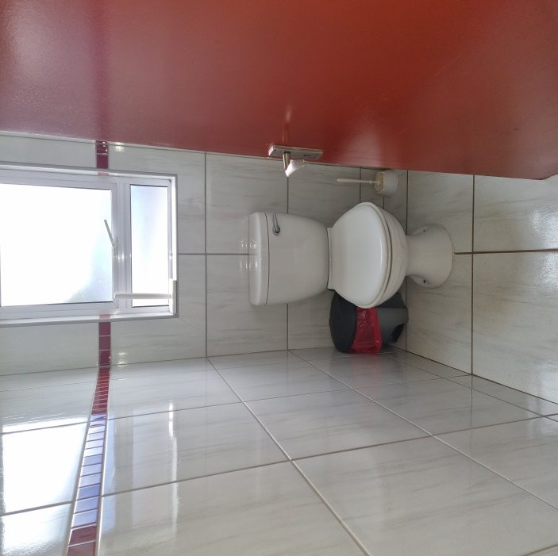
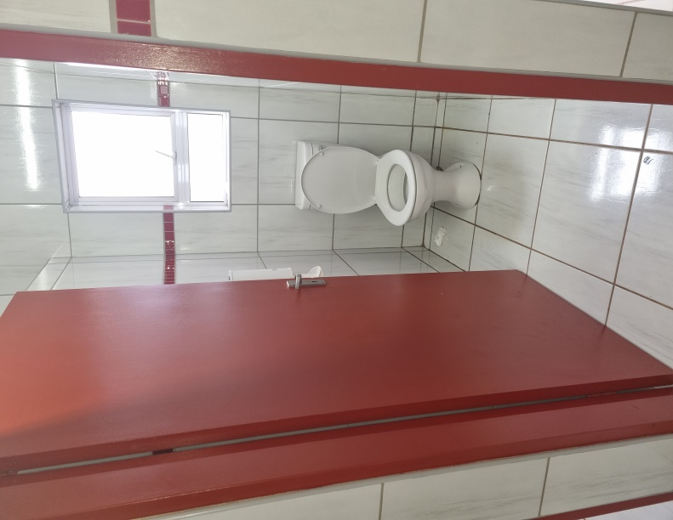
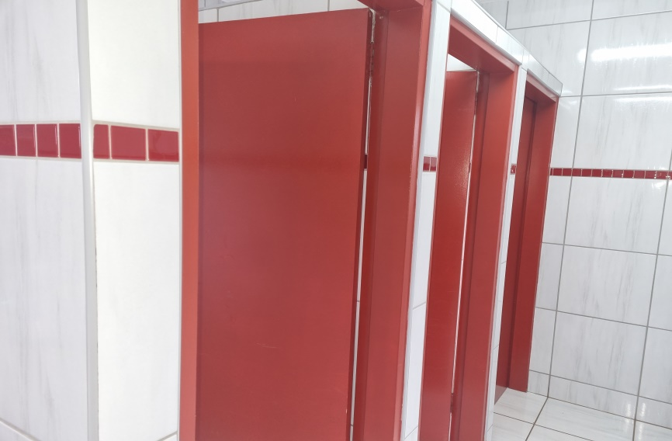
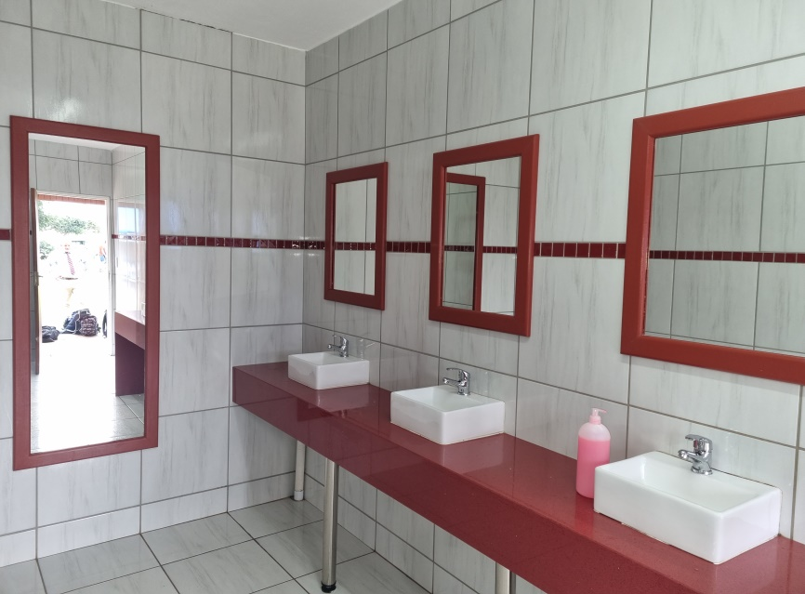
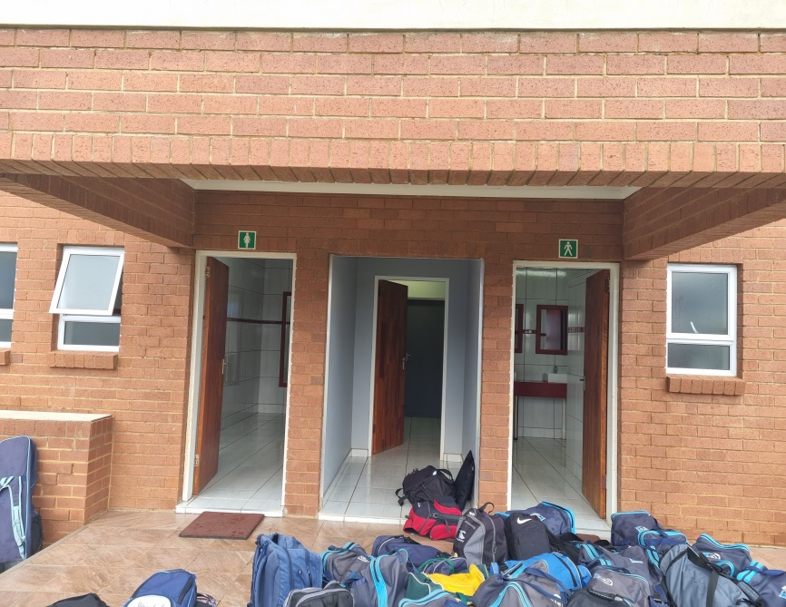
TOILETS 130 METERS AWAY FROM ESTABLISHMENT AT GYMNASIUM.
THEY ARE GOING TO BUILD TOILETS AT THE ESTABLISHMENT SHOULD THE APPLICATION BE GRANTED - LADIES PHOTO 1/2/3/4 GENTS PHOTO 5/6/7

