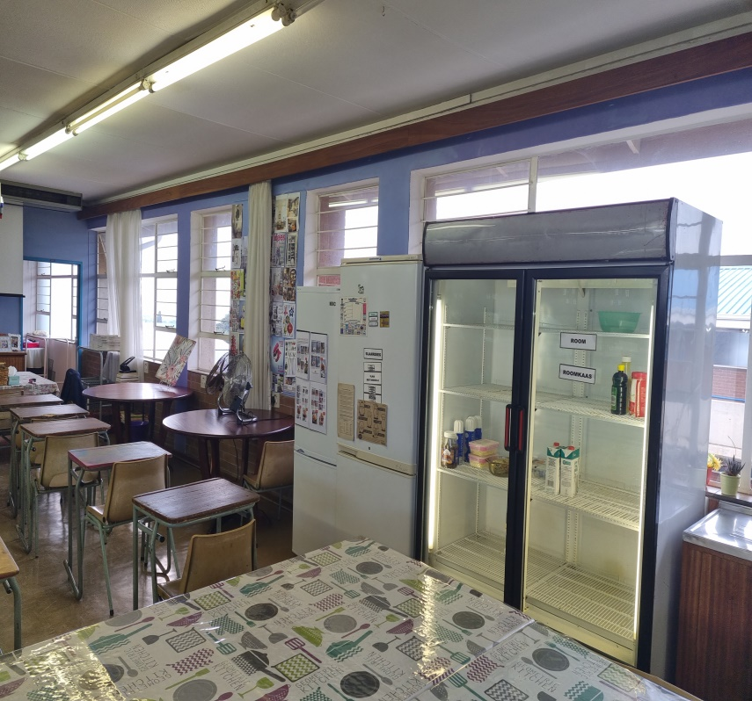
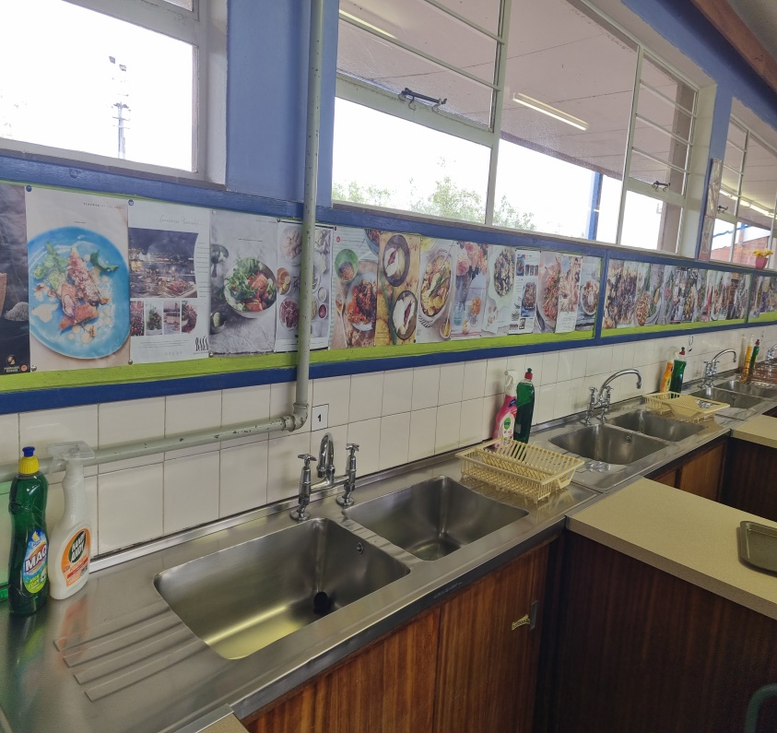
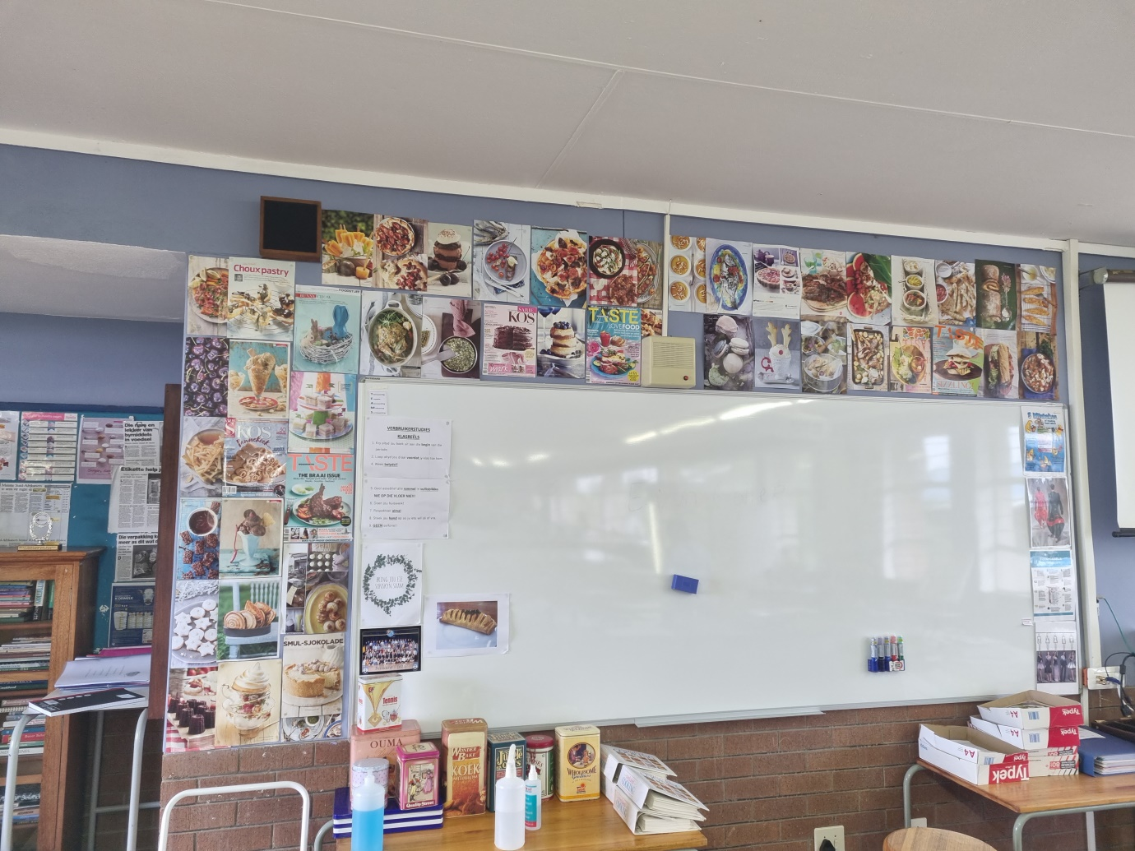
CLASSROOMS FITTED WITH ZINKS ALL ALONG COOKING STATIONS
3 FULL FRIDGES
WHITE BOARD WITH RECIPES THAT’S BEEN PRACTISED

